DBMS Practical File

Name - Pratham Sharma

Roll Number - 24/SCA/BCA(AI&ML)/051

Q1) Create a table called Employee with the following structure.

| Name | Type |
| --- | --- |
| Empno | Number |
| Ename | Varchar2(20) |
| Job | Varchar2(20) |
| Mgr | Number |
| Sal | Number |

1. Add a column commission with domain to the employee table.

2. Insert any five records into the table.

3. Update the column details of job.

4. Rename the column of Employ table using alter command.

5. Delete the employee whose Empno is 19.

Input -   
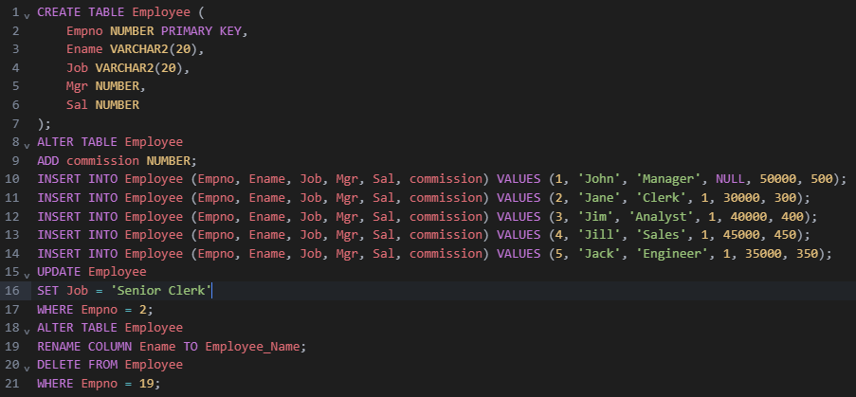

OutPut -   
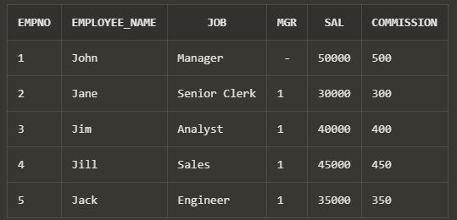

Q2) Create department table with the following structure.

| Name | Type |
| --- | --- |
| Deptno | Number |
| Deptname | Varchar2(20) |
| Location | Varchar2(20) |

1. Add column designation to the department table.

2. Insert values into the table.

3. List the records of emp table grouped by deptno

4. Update the record where deptno is 9

5. Delete any column data from the table

Input -

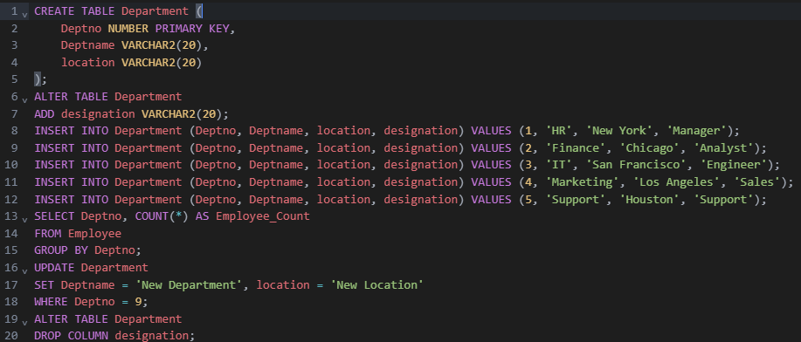

OutPut -   
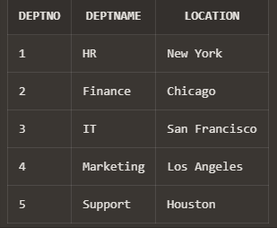

Q3) Create a table called customer table

| Name | Type |
| --- | --- |
| Cust name | Varchar2(20) |
| Cust Street | Varchar2(20) |
| Cust city | Varchar2(20) |

1. Insert records into the table

2. Add salary column to the table.

3. Alter the table column domain.

4. Drop salary column of the customer table.

5. Delete the rows of customer table whose cust city is "hyd'.

Input -

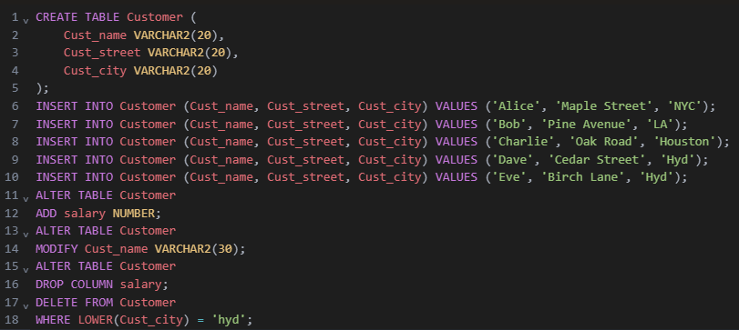

OutPut -

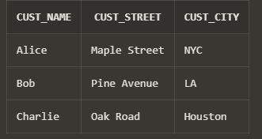

Q4) Create a table called branch table

| Name | Type |
| --- | --- |
| Branch name | Varchar2(20) |
| Branch city | Varchar2(20) |
| asserts | Number |

1. Increase the size of data type for asserts to the branch.

2. Add and drop a column to the branch table

3. Insert values to the table

4. Update the branch name column

5. Delete any two columns from the table

Input -

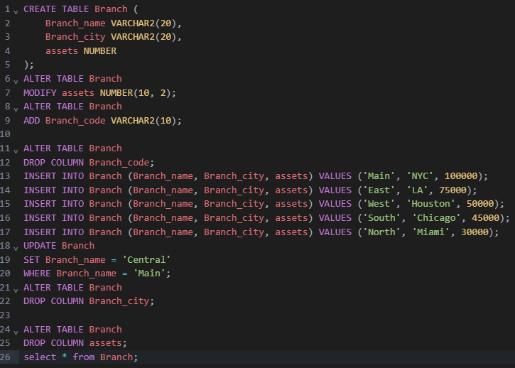

OutPut -

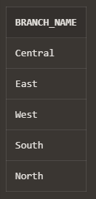

Q5) Create a table called sailor table

| NAME | TYPE |
| --- | --- |
| sID | Number |
| Sname | Varchar2(20) |
| rating | Varchar2(20) |

1. Add column age to the sailor table.

2. Insert values into the sailor table.

3. Delete the row with rating >8.

4. Update the column details of sailor.

5. Insert null values into the table.

Input -

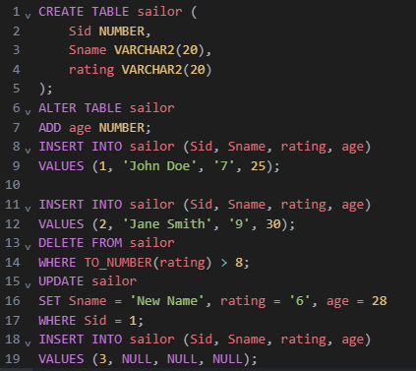

OutPut -

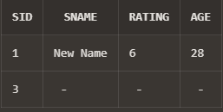

Q6) Create a table called reserves table

| NAME | TYPE |
| --- | --- |
| Boat id | Integer |
| sid | Integer |
| day | Integer |

1. Insert values into the reserves table.

2. Add column time to the reserves table.

3. Alter the column day data type to date.

4. Drop the column time in the table.

5. Delete the row of the table with some condition.

Input -

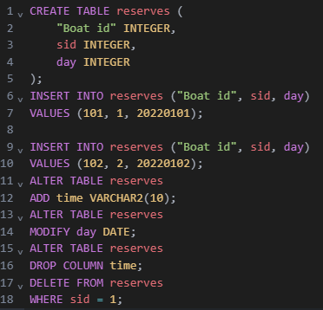

OutPut -

